SPRINT PLANNING MEETING
Introduction
Sprint planning is a key ceremony in the Scrum framework that marks the beginning of every sprint. It is a collaborative event where the Scrum Master, Product Owner, and the Development Team come together to decide what work will be taken up in the upcoming sprint and how it will be accomplished.
Purpose of Sprint Planning
The sprint planning meeting serves several important purposes.
- It helps the team understand and align on the most important work to be done in the upcoming sprint.
- It allows the team to estimate the effort required for each task and plan their capacity accordingly.
- It creates a shared commitment among all team members toward a common sprint goal.
- It provides an opportunity to clarify doubts and ambiguities in user stories before development begins.
- It ensures that the work selected is realistic and achievable within the sprint duration.
- It promotes transparency and accountability within the team from day one of the sprint.
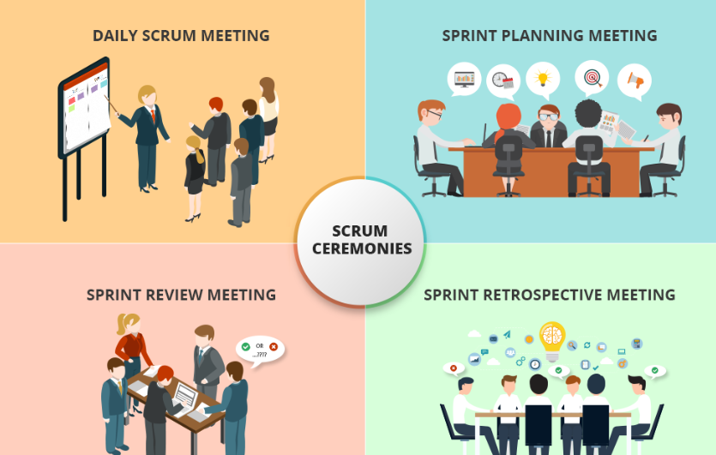

Who Attends Sprint Planning
Sprint planning is a team event and the right people must be present for it to be effective.
- Scrum Master is responsible for facilitating the meeting, keeping the discussion focused, and ensuring the team follows the Scrum process.
- Product Owner comes to the meeting with a well prepared and prioritized product backlog and explains the business value of each backlog item.
- Development Team includes all developers, testers, and designers who will be doing the work. They estimate effort, break down tasks, and commit to the sprint backlog.
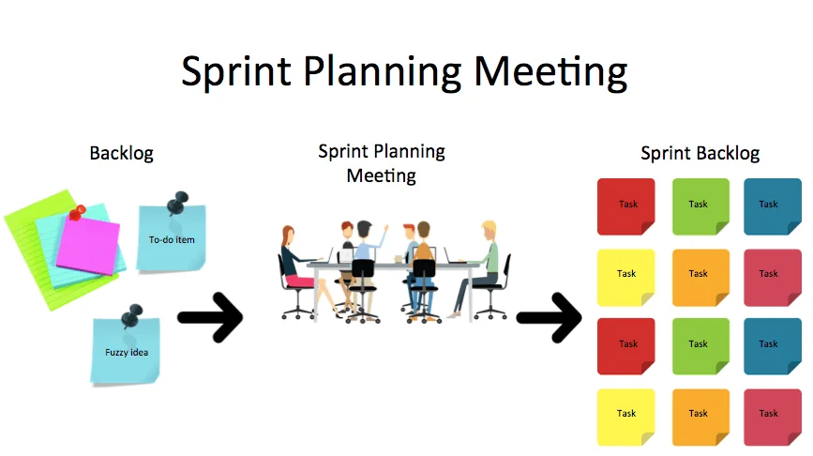
Inputs to Sprint Planning
Before the sprint planning meeting begins, certain inputs must be in place.
- The product backlog must be groomed and prioritized by the Product Owner with clear descriptions and acceptance criteria.
- The team velocity from previous sprints helps decide how much work to commit to in the current sprint.
- Team capacity must be considered including planned leaves, holidays, or other commitments.
- Dependencies, technical constraints, or blockers should be identified and discussed before finalizing the sprint backlog.
- The definition of done should be clearly established so everyone understands what completion means.
How Sprint Planning is Conducted
Sprint planning is divided into two main parts.

Part One: What Will Be Done
The Product Owner presents the top items from the product backlog. The team reviews these items, asks questions, seeks clarifications, and selects the user stories they believe they can complete by the end of the sprint. The selected stories form the sprint backlog.
Part Two: How Will It Be Done
The team breaks down each selected user story into smaller technical tasks, estimates how long each task will take, and assigns ownership. This part is driven entirely by the development team as they are the ones who know how to build the product.
Story Points and Estimation
Estimation is one of the most important activities during sprint planning. Teams use story points to measure effort and complexity.
- Planning Poker is the most widely used technique where each team member independently picks a number representing their estimate and all are revealed at the same time.
- T-Shirt Sizing categorizes tasks as extra small, small, medium, large, or extra large based on complexity.
- Bucket System is used for large backlogs where items are sorted into size buckets quickly.
- Dot Voting is a simple technique where members place dots next to items to indicate perceived effort.
Sprint Goal
The sprint goal is a short and meaningful statement that describes the overall objective of the sprint. A good sprint goal has the following characteristics.
- It is clear and easy to understand by all team members and stakeholders.
- It focuses on business value being delivered rather than just listing technical tasks.
- It is achievable within the sprint duration given the team capacity.
- It serves as a guide for the team when making decisions during the sprint.
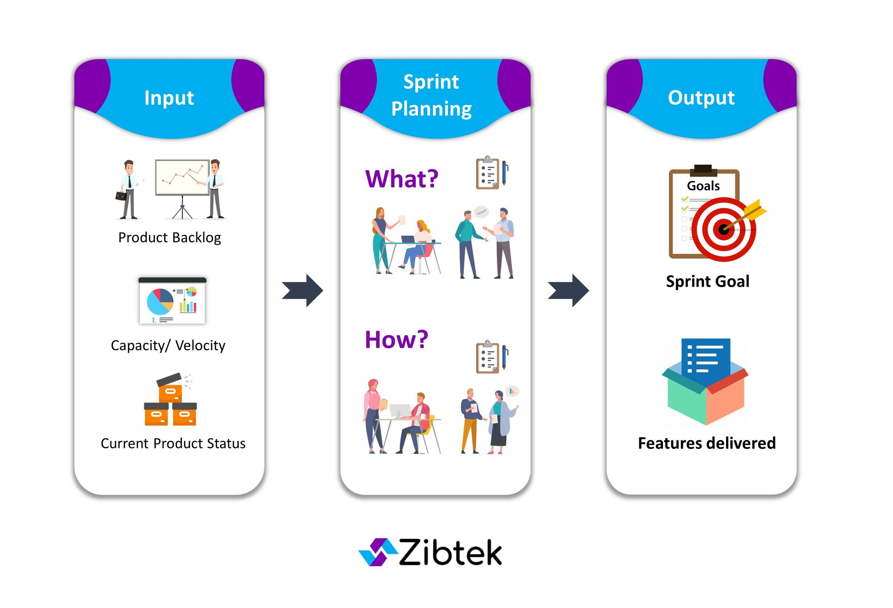
Sprint Backlog
The sprint backlog is the collection of all user stories and tasks the team commits to completing during the sprint. It should include the following.
- Selected user stories from the product backlog that align with the sprint goal.
- Detailed tasks broken down from each user story.
- Effort estimates in story points or hours for each task.
- Owner assignments indicating who is responsible for each task.
- Acceptance criteria for each user story so the team knows when it is done.
Capacity Planning
Capacity planning ensures the team does not over-commit or under-commit on work.
- The team calculates total available hours by considering the number of members, working days, and planned absences.
- Overhead activities such as daily standups, code reviews, and meetings must also be accounted for.
- Teams that consistently track their velocity become better at predicting how much work they can realistically complete.
Common Challenges in Sprint Planning
Teams often face several common issues during sprint planning.
- Unclear or poorly written user stories make it difficult to estimate effort and understand requirements.
- Over-commitment happens when the team takes on more work than they can realistically complete.
- Lack of preparation leads to long unproductive meetings where stories are refined during planning itself.
- Domination by a single person prevents collaborative decision making and leads to poor estimates.
- Ignoring dependencies can derail a sprint when external blockers are not identified early.
- Poor time management leads to rushed decisions and incomplete planning at the end of the meeting.
Best Practices for Effective Sprint Planning
- The Product Owner should groom and prioritize the backlog at least one or two days before the meeting.
- The team should review their velocity and capacity before the meeting to arrive at a realistic commitment.
- User stories should follow the INVEST criteria meaning Independent, Negotiable, Valuable, Estimable, Small, and Testable.
- The team should establish a clear definition of done before beginning the sprint.
- The meeting should be timeboxed to a maximum of four hours for a two week sprint.
- Equal participation from all team members leads to better estimates and stronger commitment.
Outcome of Sprint Planning
By the end of a successful sprint planning meeting the team should have the following.
- A clearly defined sprint goal that everyone understands and is committed to.
- A finalized sprint backlog with all selected user stories and their associated tasks.
- Effort estimates for each task and a clear picture of team capacity.
- Assigned ownership for all tasks so accountability is established from the start.
- Clarity on dependencies, risks, and any potential blockers that may affect the sprint.
- Confidence and motivation among team members to begin the sprint and deliver value.
Conclusion
Sprint planning is the foundation of a successful sprint. Teams that invest time and effort in thorough sprint planning consistently deliver better results, meet their commitments more reliably, and build stronger collaboration over time. It is one of the most valuable practices in agile development and should be treated with the seriousness and preparation it deserves.

RETROSPECTIVE MEETING
Introduction
A Retrospective Meeting is one of the most important ceremonies in the Scrum framework. It takes place at the end of every sprint and gives the team a dedicated time to reflect on how the sprint went, what went well, what did not go well, and what can be improved in the next sprint. It is essentially a meeting about the team itself rather than the product being built. The goal is continuous improvement in the way the team works together.

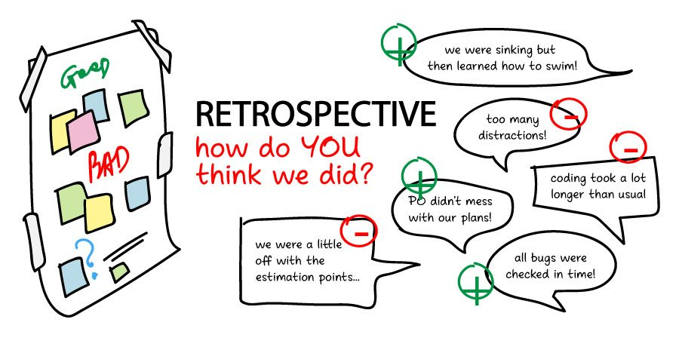
Purpose of Retrospective Meeting
The retrospective meeting serves several important purposes that help the team grow and improve over time.
- It gives the team a safe space to openly discuss what worked and what did not during the sprint.
- It encourages honest and constructive feedback among team members without blame or judgment.
- It helps identify recurring problems and root causes so they can be addressed systematically.
- It allows the team to celebrate wins and acknowledge good work done during the sprint.
- It produces actionable improvement items that the team commits to implementing in the next sprint.
- It strengthens team relationships and builds a culture of trust, transparency, and collaboration.
- It ensures the team is always learning and evolving rather than repeating the same mistakes.

Who Attends the Retrospective Meeting
The retrospective is an internal team meeting and attendance is important for all core members.
- Scrum Master facilitates the retrospective, creates a safe and comfortable environment for discussion, and ensures the meeting is productive and time-boxed.
- Development Team actively participates by sharing their honest observations, experiences, and suggestions for improvement during the sprint.
- Product Owner may or may not attend depending on the team's preference. In many teams the Product Owner attends to provide their perspective but the meeting remains focused on team process rather than product features.
- Managers or external stakeholders are generally not invited as their presence may prevent team members from speaking freely and honestly.
When is the Retrospective Meeting Held
The retrospective meeting is held at the end of every sprint after the sprint review and before the next sprint planning meeting. This timing is intentional because it allows the team to reflect on the completed sprint while the experiences are still fresh in their minds and immediately apply the improvements in the next sprint.
- For a two week sprint the retrospective typically lasts between one and two hours.
- For a one month sprint it can last up to three hours.
- The meeting should be timeboxed strictly so it does not drag on unnecessarily.
Structure of the Retrospective Meeting
The retrospective is generally structured around three core questions that guide the discussion.
What Went Well
The team discusses all the positive things that happened during the sprint. This could include successful collaboration, good communication, meeting deadlines, resolving blockers quickly, or any practice that worked effectively. Celebrating wins is important because it motivates the team and reinforces good habits.
- Team members share their positive experiences from the sprint.
- Good practices that should be continued are identified and acknowledged.
- Individual contributions and team efforts are recognized and appreciated.
What Did Not Go Well
The team honestly discusses the challenges, problems, and frustrations they faced during the sprint. This could include unclear requirements, technical debt, poor communication, missed deadlines, or any process that did not work as expected.
- Team members share pain points and obstacles they encountered.
- Issues are discussed without blame and with a focus on the process rather than individuals.
- Root causes of problems are explored to understand why things went wrong.
What Can Be Improved
Based on the discussion of what did not go well, the team identifies specific improvements they want to make in the next sprint. These are concrete actionable steps rather than vague suggestions.
- Improvement ideas are listed and discussed by the team.
- The team agrees on a small number of high priority improvements to focus on.
- Each improvement item is assigned to a responsible person with a clear timeline.
Popular Retrospective Formats
Teams use various formats and techniques to make the retrospective more engaging and effective.
- Start Stop Continue is one of the most commonly used formats where the team discusses what they should start doing, what they should stop doing, and what they should continue doing.
- Mad Sad Glad is an emotion based format where team members share what made them mad, what made them sad, and what made them glad during the sprint. This format encourages open emotional expression and empathy.
- Four Ls stands for Liked, Learned, Lacked, and Longed For. This format helps the team reflect on their experiences from multiple angles.
- Sailboat Retrospective is a visual format where the team imagines their sprint as a sailboat. The wind represents things that helped them move forward, the anchor represents things that slowed them down, rocks represent risks, and the island represents their goal.
- Five Whys is a technique used to dig deep into a problem by asking why five times in succession until the root cause is identified. It is especially useful when the team is trying to understand why a particular issue keeps repeating.
- Timeline Retrospective involves creating a visual timeline of events during the sprint and having team members mark positive and negative moments. It helps the team see patterns and understand the flow of the sprint.
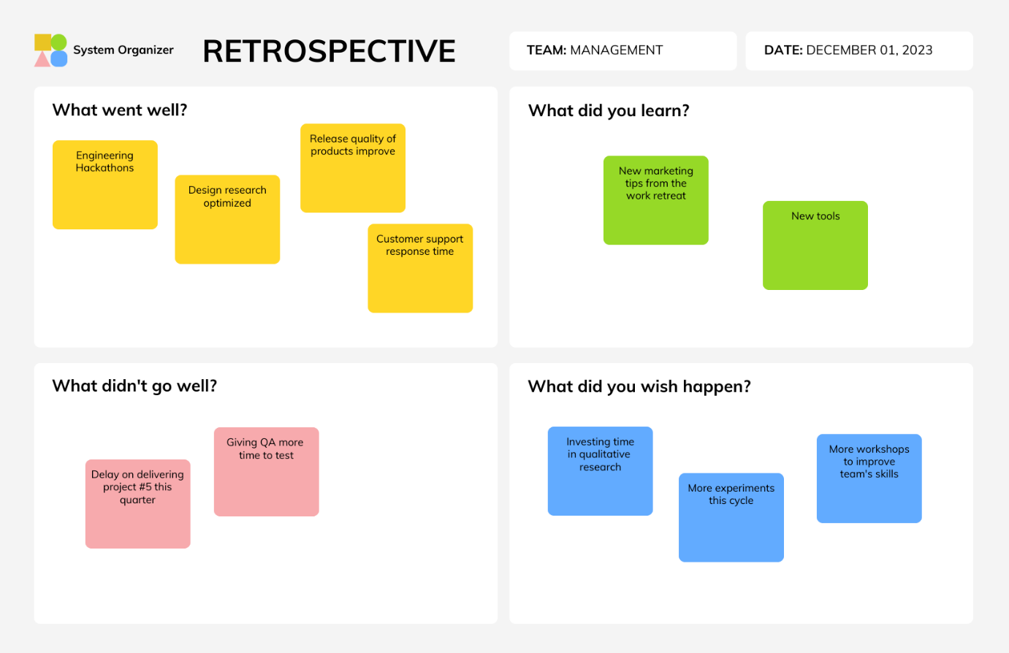
Action Items and Improvement Plan
The most important output of a retrospective meeting is the list of action items that the team commits to implementing in the next sprint. Without concrete action items the retrospective becomes just a venting session with no real impact.
- Action items should be specific, measurable, and realistic.
- Each action item should have a clear owner who is responsible for ensuring it is implemented.
- The number of action items should be kept small, ideally two to three per sprint, so the team can actually follow through on them.
- Action items from the previous retrospective should be reviewed at the start of the next retrospective to check if they were implemented.
- If an action item was not completed it should be carried forward and prioritized in the next improvement plan.
Role of the Scrum Master in the Retrospective
The Scrum Master plays a critical role in making the retrospective a safe, productive, and meaningful experience for the team.
- The Scrum Master sets the tone by creating a judgement free environment where everyone feels comfortable speaking honestly.
- They facilitate the discussion by asking the right questions, encouraging quieter team members to share their views, and preventing any one person from dominating the conversation.
- They keep the meeting focused and on track so that it does not turn into a blame session or a complaint forum.
- They help the team prioritize improvement ideas and arrive at actionable commitments.
- They follow up on action items from previous retrospectives to ensure the team is actually improving and not just talking about it.
Common Challenges in Retrospective Meetings
Retrospectives can lose their effectiveness if not conducted properly. Teams often face the following challenges.
- Team members may feel uncomfortable sharing honest feedback especially if there is a fear of blame or conflict.
- The same issues keep coming up in every retrospective without any real improvement because action items are not followed through.
- The meeting becomes repetitive and boring over time if the same format is used every sprint without any variation.
- Dominant personalities may overshadow quieter team members leading to incomplete or biased feedback.
- The retrospective is sometimes skipped when the team is under pressure or running short on time which defeats the purpose of continuous improvement.
- Action items are too many or too vague and the team ends up not implementing any of them.
Best Practices for Effective Retrospective Meetings
Following best practices ensures that the retrospective delivers real value to the team.
- Create a safe and open environment where team members feel free to share their honest thoughts without fear of judgment.
- Use different retrospective formats in different sprints to keep the meeting fresh and engaging.
- Keep the focus on processes and systems rather than individuals to avoid blame and defensiveness.
- Limit the number of action items to two or three so the team can realistically follow through on them.
- Always review action items from the previous retrospective at the start of the next one to track progress.
- Encourage equal participation from all team members by using techniques like round robin sharing or anonymous feedback tools.
- Timebox the meeting strictly so it does not run overtime and lose the team's energy and focus.
- Document the outcomes of every retrospective and make them visible to the team throughout the sprint.
- Vary the location or format of the retrospective occasionally to break the routine and boost engagement.
Outcome of the Retrospective Meeting
By the end of a well conducted retrospective meeting the team should have achieved the following outcomes.
- A shared understanding of what went well during the sprint and what practices should be continued.
- A clear picture of the problems and challenges faced during the sprint and their root causes.
- A prioritized list of two to three actionable improvement items for the next sprint.
- Assigned owners and timelines for each improvement action item.
- A stronger sense of team cohesion, trust, and mutual respect among all members.
Conclusion
The retrospective meeting is the heartbeat of continuous improvement in agile teams. It is the one ceremony that focuses entirely on the team rather than the product and gives everyone a voice in shaping how they work together. When conducted well and consistently, retrospectives help teams build better habits, resolve recurring problems, and grow stronger with every sprint. Teams that take their retrospectives seriously are the ones that consistently improve their performance, their relationships, and the quality of the work they deliver.

DAILY STANDUP MEETING
Introduction
The Daily Standup Meeting, also known as the Daily Scrum, is a short and focused meeting that takes place every single day during a sprint. It is one of the five key ceremonies in the Scrum framework and is designed to keep the team aligned, informed, and focused on the sprint goal. The meeting is called a standup because traditionally the team stands up during the meeting to keep it short and energetic. It typically lasts no more than fifteen minutes and is held at the same time and place every day.
Purpose of the Daily Standup Meeting
The daily standup serves several important purposes that help the team stay on track throughout the sprint.
- It keeps all team members informed about what everyone is working on so there are no surprises or duplications of effort.
- It helps the team identify blockers and obstacles early so they can be resolved quickly before they impact the sprint.
- It promotes accountability among team members by having everyone publicly commit to what they will accomplish that day.
- It strengthens team communication and collaboration by creating a daily touchpoint for the entire team.
- It helps the Scrum Master identify impediments that need to be addressed on behalf of the team.
- It keeps the team focused on the sprint goal and ensures daily progress is being made toward it.
- It replaces the need for long status update emails or unnecessary check-in meetings throughout the day.
- It creates a rhythm and routine that keeps the team disciplined and consistent throughout the sprint.
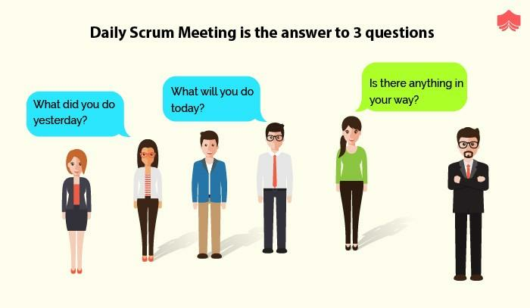
Who Attends the Daily Standup
The daily standup is primarily a meeting for the development team but other roles may also be present.
- Development Team are the core participants who are required to attend and actively contribute to the standup every day.
- Scrum Master attends to facilitate the meeting, ensure it stays within the timebox, and note any impediments that need to be resolved.
- Product Owner may attend to stay informed about progress but should not interrupt or dominate the conversation.
- Stakeholders and managers may observe the standup but should not speak during the meeting as it is purely a team synchronization event.
The Three Core Questions
The daily standup is structured around three core questions that each team member answers one by one. These three questions give the meeting its focus and ensure the discussion stays relevant and brief.
What did I do yesterday?
Each team member briefly shares what they accomplished on the previous working day. This gives the rest of the team visibility into the progress being made and ensures everyone is aware of completed work. It also creates a sense of accountability as team members know they will be reporting their progress to the group every day.
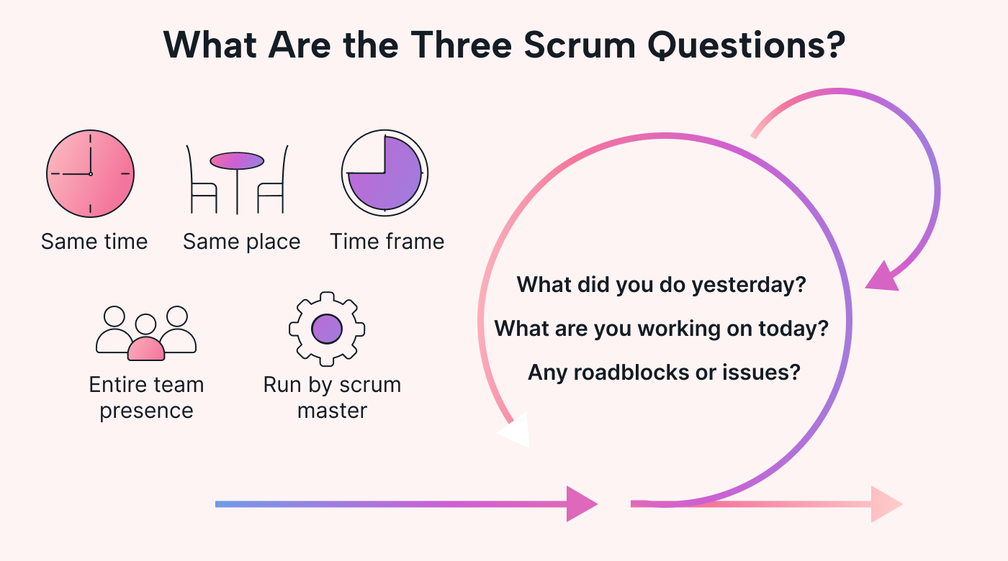
What will I do today?
Each team member shares what they plan to work on during the current day. This helps the team understand where everyone's focus is and allows for quick coordination if two people are working on related tasks. It also helps team members set a clear intention for the day and stay focused on meaningful work.
Are there any blockers or impediments?
Each team member shares any obstacles that are preventing them from making progress. This is the most critical part of the standup because blockers can slow down or completely halt work if not addressed quickly. The Scrum Master takes note of all blockers mentioned and works to resolve them after the standup is over.
Format and Timing of the Daily Standup
The daily standup follows a very specific format to ensure it stays efficient and focused.
- The meeting is held at the same time every day, preferably in the morning, so the team can plan their day accordingly.
- It is strictly timeboxed to fifteen minutes regardless of the size of the team.
- Each team member speaks briefly and to the point without going into detailed technical discussions.
- Any topics that require deeper discussion are taken offline after the standup in a separate conversation between the relevant team members.
- The meeting is held standing up to discourage lengthy discussions and keep energy levels high.
- It is held in person whenever possible but can also be conducted virtually using tools like Microsoft Teams, Zoom, or Slack.
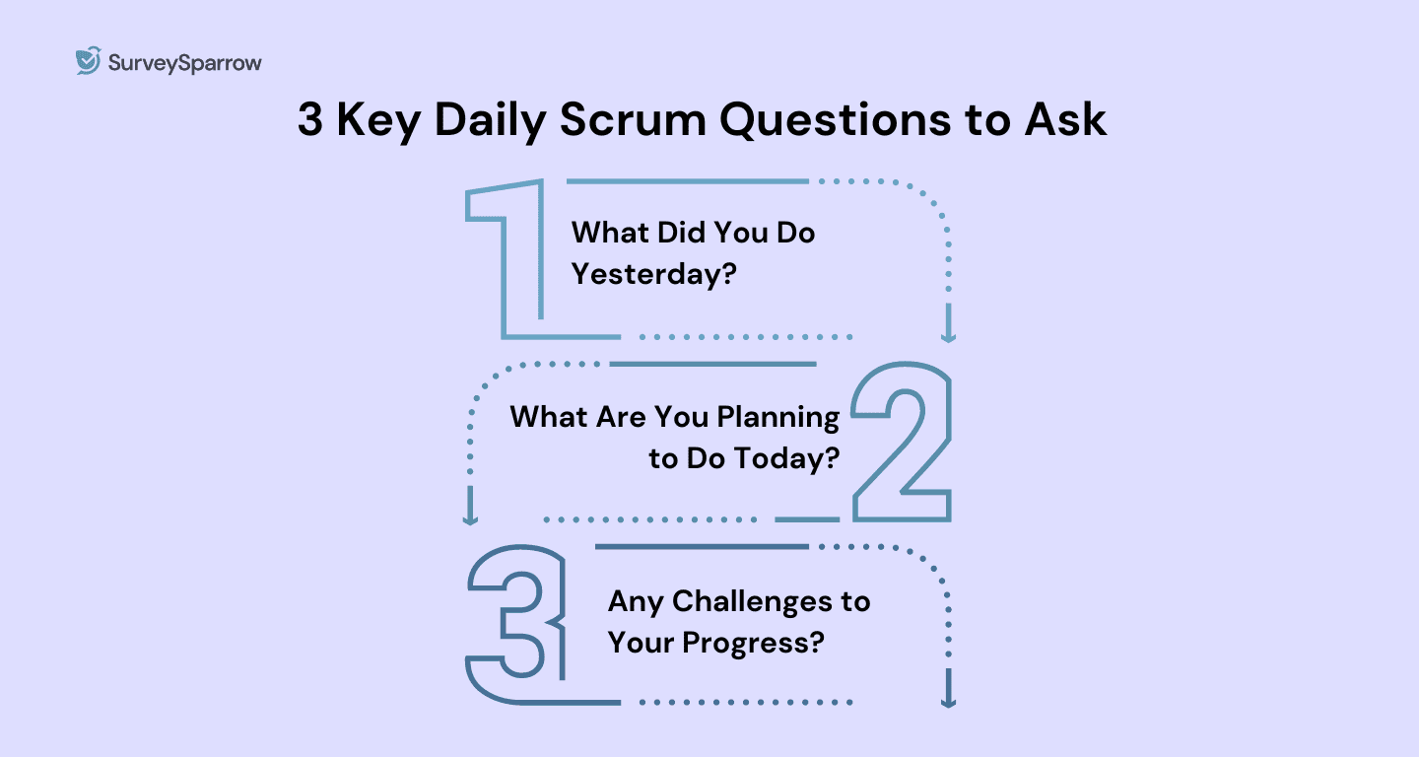

Types of Daily Standup Formats
While the traditional three question format is the most widely used, teams sometimes adopt variations based on their needs and preferences.
- Walking the Board is a format where the team goes through the sprint board task by task instead of person by person. Each task is discussed in terms of its current status, who is working on it, and whether there are any blockers. This format keeps the focus on the work rather than the individuals.
- Round Robin is the classic format where each team member takes turns answering the three core questions one after another until everyone has spoken.
- Asynchronous Standup is used by remote or distributed teams where team members post their updates in a shared channel such as Slack or Microsoft Teams at a specified time instead of meeting in real time. This is particularly useful for teams spread across different time zones.
- Signal Standup is a format where team members use visual signals such as colored cards or flags to indicate their status before speaking. Green means everything is on track, yellow means there are concerns, and red means there is a blocker. This gives the Scrum Master and team a quick visual overview before the discussion begins.
Role of the Scrum Master in the Daily Standup
The Scrum Master plays an important but subtle role in the daily standup.
- They facilitate the meeting and ensure it starts and ends on time every day without exception.
- They ensure the conversation stays focused on the three core questions and does not drift into lengthy technical debates.
- They listen carefully for blockers and impediments mentioned by team members and take responsibility for resolving them after the meeting.
- They encourage quieter team members to speak up and ensure everyone has an equal chance to share their update.
- They protect the team from external interruptions and distractions during the standup.
- They do not run the standup as a status report to management but keep it as a team synchronization event owned by the development team.
Common Mistakes in Daily Standups
Many teams fall into common traps that reduce the effectiveness of their daily standup.
- Turning the standup into a status report where team members report to the Scrum Master or manager instead of talking to each other.
- Going over the fifteen minute timebox by allowing lengthy technical discussions during the meeting instead of taking them offline.
- Skipping the standup on busy days which breaks the team's rhythm and leads to a lack of synchronization.
- Team members giving vague updates like "I am working on the same thing as yesterday" without providing meaningful information about progress or blockers.
- Not following up on blockers mentioned during the standup which defeats the entire purpose of raising them in the first place.
- Having too many people speak during the standup including non-team members which extends the meeting and dilutes its focus.
- Conducting the standup while sitting down which psychologically encourages longer discussions and reduces the sense of urgency to keep it brief.
Benefits of a Well Conducted Daily Standup
When done correctly the daily standup delivers significant benefits to the team and the overall sprint.
- It dramatically reduces the need for lengthy status update meetings and unnecessary interruptions throughout the day.
- It creates a strong sense of team unity and shared purpose as everyone is aware of what the whole team is working toward.
- It enables early detection of risks and blockers so they can be addressed before they escalate into serious problems.
- It improves individual accountability as each team member knows they will be sharing their progress with the group every day.
- It helps the team build a consistent daily routine that improves discipline and focus throughout the sprint.
- It gives the Scrum Master real time visibility into the health of the sprint and the team's progress toward the sprint goal.
- It fosters a culture of open communication where team members feel comfortable sharing challenges and asking for help.
Tools Used for Daily Standups
Teams use various tools to support their daily standup especially in remote or hybrid work environments.
- Jira is widely used to display the sprint board during the standup so the team can visually track task progress and update statuses in real time.
- Microsoft Teams and Zoom are used for virtual standups where team members join a video call to conduct the meeting remotely.
- Slack is used for asynchronous standups where team members post their updates in a dedicated channel using a standup bot or manual messages.
- Trello is a simple visual board tool used by smaller teams to track tasks and updates during the standup.
- Standup bots like Geekbot or Standuply are used to automate asynchronous standups by sending daily prompts to team members and collecting their responses in a shared channel.
Best Practices for an Effective Daily Standup
Following best practices ensures the daily standup remains valuable and does not become a dreaded routine.
- Hold the standup at the same time and place every day to build a consistent habit within the team.
- Keep it strictly to fifteen minutes and cut off discussions that go beyond the scope of the three core questions.
- Focus on blockers and ensure every blocker mentioned is followed up on and resolved as quickly as possible.
- Encourage team members to update the sprint board before the standup so the discussion is based on current and accurate information.
- Rotate the order in which team members speak to keep the meeting fresh and ensure no one always goes first or last.
- Use the standup to reinforce the sprint goal and remind the team of what they are working toward collectively.
- Keep the energy positive and constructive so the standup starts the day on a good note for the entire team.
- Avoid scheduling the standup too early in the morning or too late in the day so that all team members can attend comfortably.
Outcome of the Daily Standup
By the end of a well conducted daily standup the team should have achieved the following outcomes.
- Every team member has a clear understanding of what others are working on and the overall progress of the sprint.
- All blockers and impediments have been surfaced and the Scrum Master has taken ownership of resolving them.
- Team members have a clear plan for their own work for the rest of the day.
- Any coordination needed between team members has been identified and arranged.
- The team feels aligned, motivated, and ready to make meaningful progress toward the sprint goal for the day.

Conclusion
The daily standup meeting is a small but powerful practice that keeps agile teams synchronized, accountable, and focused every single day. When conducted with discipline and respect for the timebox it becomes one of the most valuable habits a team can build. It is not just a check-in but a daily commitment to collaboration, transparency, and continuous progress. Teams that run effective standups consistently find it easier to meet their sprint goals, resolve problems faster, and maintain a strong sense of shared purpose throughout the sprint.

